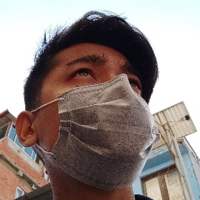C.V(Bio Data)

Nelson Ale Magar

Bachelor in Cyber Security and Networking (BCS)

1. **Personal Details:**

Father’s Name : Chandra Bahadur Magar

Mother’s Name : Pankhi Kumari Pun Magar

Date of Birth : 2058/11/28

Nationality : Nepali

Gender : Male

Citizenship Number : 35-01-75-00616

Contact Number : 9822573800

Address : Bharatpur-12, Chitwan

Email : nelsonmagar99@gmail.com

1. **Objective:**

To secure a challenging position in a reputable organization to extend my learning, knowledge, and skills.

1. **Education:**

Bachelor’s Degree:

Forbes College (Swiss Board)

Kshetrapur, Chitwan, Nepal.

BCS 1st semester running...

Higher Secondary Level (+2)

Orchid College (NEB Board)

Bharatpur-10, Chitwan.

GPA: 2.81

SEE Level:

Prerana Higher Secondary School.

Bharatpur-12, Chitwan.

GPA: 2.90

Completed Year: 2074 BS (2018 AD)

1. **Training and Experience:**

Took a training for Graphic Designing.

Had worked in A2Z mobile house for 6 month as technical assistant.

1. **Other Knowledge and Skill:**

Basics of Premiere Pro.

Driving, playing ukulele.

1. **Reference:**

**-**Mohan Lama of Prerana Higher Secondary School, Bharatpur-12, Chitwan.

**-**Hari Saran Pathak of Forbes College, Bharatpur-2, Kshetrapur, Chitwan.